In order to work remotely (outside of the branch) you must have MFA set up (Microsoft Authenticator).

25 January 2022

**Terra Industrial New Zealand Ltd**

PO Box 16 168

16 Branston Street, Hornby

Christchurch 8441, New Zealand

03 983 2333 Tel

www.TerraCat.co.nz

**Connecting Remotely**

Outside of the branch

**What is MFA?**

A security measure to prove that it is you signing in and not a hacker. Makes it more difficult for hackers to access your account.

When attempting to sign into your account, you will get a notification on your phone that looks something like the below that you would need to “approve”.

If a hacker was trying to get into your account, they would need your phone to approve the sign in themselves.

If you have a company mobile phone, the app should already be installed.

If you don’t have a company phone, you will need to download the app.

See instructions below on how to set up MFA – this needs to be done while in the branch on the network.

Contents

MFA Setup (Microsoft Authenticator) 3

Option 1 – Always On VPN (Automatic connection) 6

Option 2 – GGH VPN 6

Option 3 – citrix.ggh.co.nz (Can use on work or personal computer) 7

Option 4 – Laptop Sim Card (Excessive usage can incur extra charges) 11

# MFA Setup (Microsoft Authenticator)

1. On your computer > go to <https://aka.ms/mfasetup>
2. Type in your work email address below then click **Next**

1. Type in your computer password below then click **Next**

1. On the Stay signed in click **Yes**

1. You should now have landed at the screen below > click **Next**

1. Go into the app on your phone and click on “**Add account**” > select “**work or school account**”
2. You will now be asked to scan a QR code
3. On your computer > click **next**

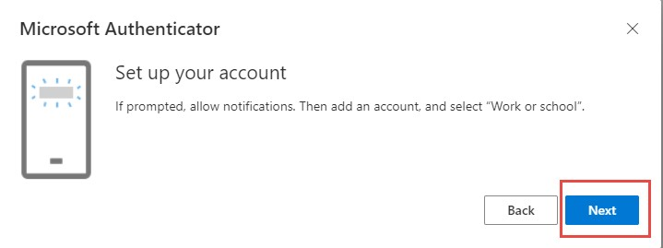

1. You will now be displayed a QR code that your phone needs to scan

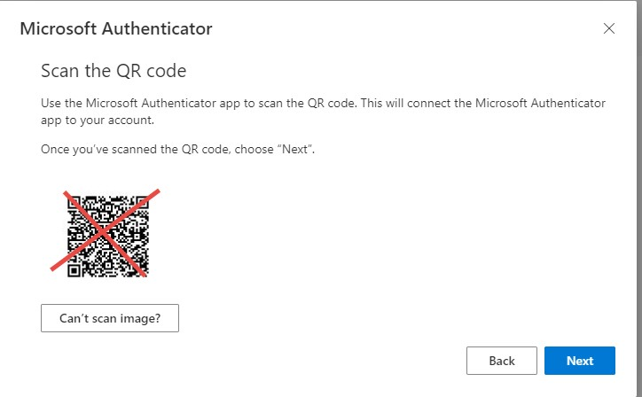

1. Once the QR code has been scanned and it says “**account added successfully**” > click **Next** on your computer
2. You should then receive a pop-up notification on your phone to “**approve or deny**” sign in > click “**approve**”

**Setup is now complete**

# Option 1 – Always-On VPN (Automatic connection)

Once connected to your home WIFI, the Always-On VPN automatically starts to connect your computer to our network in the background.

*Note in some cases it can take up to 5 mins for everything to fully connect*

To test it is working, go to your shared drives and try to open the P Drive.

Then use your computer as if you were at work.

If you find that the drives and outlook etc will not connect, try restarting your computer, like below:

# Option 2 – GGH VPN

If you find the always-on VPN is not working as expected, another option is to use our old VPN

To use:

1. Find this icon on your desktop Logo

   Description automatically generated with medium confidence
2. Use your computer username and password and click “Connect”

1. The progress bar will stop at 45% and an MFA request will be sent to your phone to approve.

1. Once you tap approve on your phone the VPN will continue to 100% and your computer will be connected to our network.

# Option 3 – citrix.ggh.co.nz (Can use on work or personal computer)

Note: Depending on what device you are using some of these initial steps may not be required, continue through the steps until you get to the one that makes sense for you.

1. Go to the website [https://citrix.ggh.co.nz](https://citrix.ggh.co.nz/)
2. This will then take you to a Microsoft Login Page for MFA.
3. Put in your email address, (if “name”@terracat.co.nz does not work try the email you had before the rebranding).

1. Click next and then put in your password
2. You will then be prompted to approve a request on your phone.

1. After approving you will now get taken to the Citrix website
2. If Citrix Receiver is not installed on your computer, you will need to download the install file and install it on your computer by following the prompts.

1. If you have a work laptop or have already installed it on your personal computer, click Detect Receiver, it may prompt you to click “Open Citrix Workspace Launcher” (or similar wording).

1. This will take you to the Citrix StoreFront where you can launch company programs. Click on the Desktops tab at the top and select Gough Group Desktop.

1. This will open a virtual computer desktop that has access to network drives, emails, and everything you should need to work remotely.

1. To disconnect or make the Gough Group Desktop Fullscreen find the small tab at the top of the window to pull down some options to choose from.

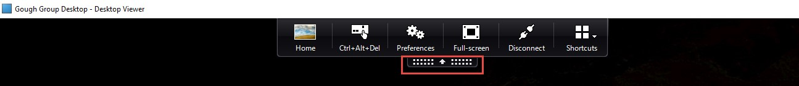

# Option 4 – Laptop Sim Card (Excessive usage can incur extra charges)

When connected with the laptop sim card, your computer will automatically connect with the company network.

To see if you have a sim card installed, go into your Wi-Fi menu in the bottom right-hand corner of your computer and look for Vodafone NZ (LTE)

If it says “no sim is installed” or “account not active” you will need to discuss with your manager who can request a Sim from the Service Desk (there is a monthly cost for this)

By default, in Windows 10, if you are not connected to Wi-Fi, it should automatically connect to the sim card. If you want to control when the sim connects, go into the Wi-Fi menu, click Vodafone, and untick the “Let Windows keep me connected” option.